St George’s C of E (VC)
Primary School

Whole School
Curriculum Planning

Bringing faith and education together
‘Letting our light shine’ (Matthew 5:16)


St. George’s Church of England Primary School – Long Term Planning EYFS Year R

 | Term 1  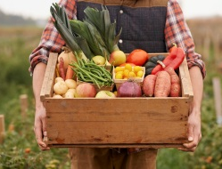  Autumn & Harvest | 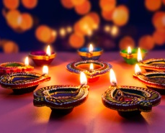  Term 2  Festivals | 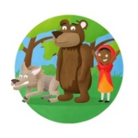  Term 3  Traditional Tales | Term 4  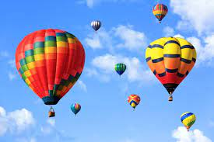  Journey | Term 5  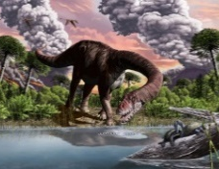  Dinosaurs | Term 6  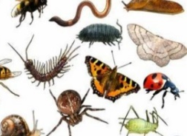  Minibeasts
Experiences | Visit to local shops | Diwali workshop | Theatre company performance | Go on a train ride | Archaeological dig (replicate) | Visit to farm. Fruit Picking
Planned vocabulary | Harvest, Autumn, season, crop, gathering | Hindu, rangoli pattern, sari, mosque | Setting, characters, long ago, enchanting, kingdom | Vehicles, location, distance, destination | Palaeontologist, fossils, prehistoric | Insect, Abdomen, chrysalis
Communication and Language | Harvest performance to parents | Show & Tell  Nativity Performance to parents & school.  Speech & Language interventions | Show & Tell  Easter performance to parents & school.  Speech & Language interventions | Show & Tell  Speech & Language interventions | Show & Tell  Speech & Language interventions | Show & Tell  Asking & answering questions.  Speech & Language interventions
Computing | In EYFS, children have access to a range of computing tools to explore in their environment, such as iPads and the interactive whiteboard.  During their Guided Reading session, which takes place 3 times a week, they will use the iPad to read in small groups with an adult.  They will also learn how to explore the iPads through playing a variety of phonics and number games.  Throughout the year, the children will practice how to log onto a computer with their username and password to prepare them for their transition into Year 1.
Physical Development | BEAM  Using space  Writing own name  Correct pencil grip  Toileting & washing hands | Forest school sessions  Dancing and creating dances  Cutting skills  Hygiene for cooking, healthy food choices  Letter formation | Forest school sessions  Gymnastics & apparatus  Balancing, moving  Staying safe  Handwriting fluency | Forest school sessions  Gymnastics & apparatus  Building core strength  Oral care  Moving under, over, above, below  Handwriting fluency | Forest school sessions  Ball Games  Coordination, team games  Handwriting fluency | Forest school sessions  Sports Day  Handwriting fluency
Personal, Social & Emotional Development | Colour Monster- awareness of feelings | Celebrate uniqueness-different cultures ‘I am special’ | Show confidence, perseverance and resilience | Show understanding of healthy choices | Follow direction/instructions. Give to a friend | Transition ‘ready to spread my wings’
Religious Education | Creation  Why is the word ‘God’ so important for Christians? | Incarnation  Why do Christians perform Nativity plays at Christmas | New Testament Stories  Which stories are special and why? | Salvation  Why do Christians put a cross in an Easter Garden? | Old Testament Stories  Which stories are special and why? | World Faith Stories  Which stories are special and why?

Literacy | Selection of rhymes and story  Hearing initial sounds, final sounds,  sound talking cvc words.  Phase 1 revisit  Phonics Phase 2  s a t p i n m d g o c k ck e h r | Writing labels, captions, shopping lists.  Letter to Father Christmas.  Phase 2 u l f b  Revise Phase 2  Phase 3 j v w x y z  qu ch sh ai OO oo  ee or ar ur | Segmenting and blending  Story mapping & hot seating  Instructions recipe  Wring labels, captions and sentences  Story telling language and phrases,  story retelling  ow oi ear air ure  Revise Phase 3 | Wring labels and captions  Writing facts  Phonics Phase 4 | Phonics, reading, writing,  segmenting and blending  Wring labels, captions, postcards  Writing speech bubbles  Acting out  Phonics Phase 4 | Writing facts  Story telling language and phrases  Sentences need a capital letter, full stop, finger spaces. Read through to check it makes sense.  Phonics Phase 4
Mathematics | Introduce Numberblocks  Mathematic challenges in an enabling environment  Counting, ordering, subitising Composition of numbers 1 to 5  Shape and pattern  Counting and number songs  Ordering number recognition, counting objects. | Numberblocks programmes  The number of a group can be changed by adding to it or taking from it.  Addition and subtraction of 1  Number bonds to 5  Counting, ordering & subitising  Addition & subtraction of numbers to 5  Number bonds to 5  Continue a pattern & colours | Numberblocks programmes  Counting (1 to 10)  Structure of square numbers (4 & 9)  Partitioning and combining. Adding and finding one more  10 ones are equivalent to one 10. 2D shape names and properties  Counting & number recognition to  20, one more, one less  Solving problems | Numberblocks programmes  Doubling and Equal groups Partitioning 8 into equal groups. Partitioning 9 into 3 equal groups  Partitioning is the inverse of Combining. Odd and even numbers  Subtracting 2 from numbers up to 10  Counting in 2s  Comparing capacities and volumes | Numberblocks programmes  Comparison of numbers 1 to 5 using the language of ‘greater than’ and ‘less than’  Composition of numbers to 5. Exploring the part-part-whole model  to partition & combine numbers to 5  Introducing the concept of zero  Solving problems: measuring | Numberblocks programmes  Comparison of numbers to 10 using the language of ‘bigger than’, ‘smaller than’ leading to ‘greater than’ and ‘less than’. Pairs of numbers that total 10  3D shape names and properties  Problem solving: doubling, halving, sharing equally. Addition &  subtraction problems
Understanding the World | Where do our fruit and vegetables come from?  Origins of different foods | Understanding different cultures & enjoy different things  Understanding reflection  Look closely at similarities,  differences, patterns and change | Understanding differences and similarities between make believe and their own world  Babies: How do we care for babies  What do they need?  Cooking changing state | Parts of a daffodil, roots, shoot, flower, petals  Seasons—signs of spring  How do we look after ourselves?  How do we stay healthy? What should we eat? | Different places, environments &  Countries. How do you send a letter/postcard?  Paying for tickets, passports to travel to different countries  London—capital city.  Maps and getting around | Protect our world and environment  Recycling  All living things need water … what else?  Talk about changes in the weather and seasons  Lifecycles
Expressive Art & Design | Leaf printing  Fruit and veg art/ printing  Explore colour mixing | Rangoli Patterns  Christmas Art  Acting in Nativity play Learning songs  Creating dances  Explore colour mixing | Create the Three Little Pigs’ Houses in  different materials  Design and create fairy tale props  Video/photograph acting out stories  Story Teller’s chair, dramatic story telling | Daffodil real-life drawings  Photography (iPad photos)  Look at a range of artists | Planning, designing & making a fantasy vehicle from junk | Mini-beast art  Listen to “Flight of the Bumble Bee”  Create a Bee dance

St. George’s Church of England Primary School – Long Term Planning Beech Class Year 1
Year 1 | Autumn Term 1 |  | Autumn Term 2 |  | Spring Term 1 |  | Spring Term 2 |  | Summer Term 1 |  |  | Summer Term 2
Christian Value | Respect |  | Courage |  | Kindness |  | Forgiveness |  | Honesty |  |  | Hope
English text | 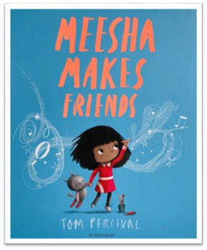​  Meesha Makes Friends​  by Tom Percival |  | 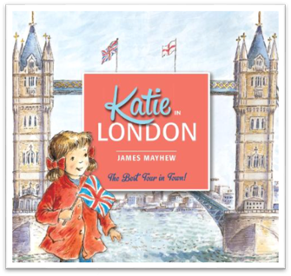  Katie in London​ by James Mayhew |  | 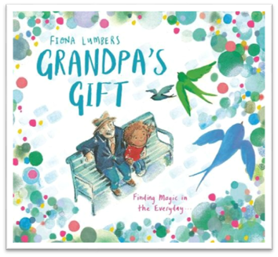  Grandpa’s Gift by Fiona Lumbers |  | 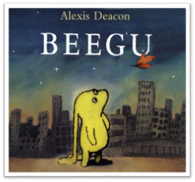  Beegu​ By Alexis Deacon |  | 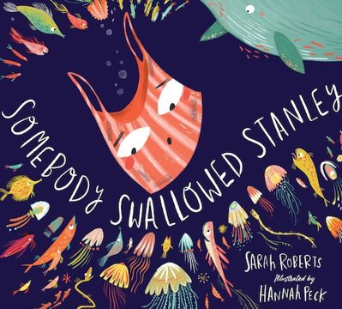  Somebody Swallowed Stanley ​By Sarah Roberts​ |  |  | 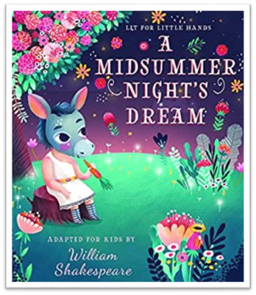  A Midsummer Night’s Dream ​Text adapted by Brooke Jorde
Maths | Number:  Place Value (within 10) | Number:  Addition and Subtraction (within 10) | Geometry: Shape | Number:  Place Value (within 20) | Addition and Subtraction (within 20) | Number:  Place Value (within 50) | Measurement:  Length and Height | Measurement:  Weight and Volume | Number: Multiplication and Division | Number: Fractions | Geometry: Position and Direction | Number:  Place Value (within 100) | Measurement: Money | Measurement:  Time
Science | Forces and space:  Seasonal changes |  | Materials: Everyday materials |  | Materials: Everyday materials |  | Animals: Comparing animals |  | Plants: Introduction to plants |  |  | Making connections: Investigating through science
RE | God  What do Christians believe God is like? |  | INCARNATION Why does Christmas matter to Christians?  (Core / Digging Deeper) |  | Gospel  What is the good news Jesus brings?  (Core / Digging Deeper) |  | Salvation  Why does Easter matter to Christians?  (Core) |  | Judaism  Who is Jewish and what do they believe?  (Part 1) |  |  | Judaism  Who is Jewish and what do they believe?  (Part 2)
Geography | Why we love Wrotham  What makes Wrotham unique? |  |  |  | Brilliant Britain  How is where we live different to Rochester? |  |  |  | African Adventure  Where would you prefer to live and why? (Great Britain or Kenya?)
History |  |  | How am I making History? |  |  |  | Brilliant Britain  What has been learned from The Great Fire of London? |  |  |  |  | How have explorers changed the world?
Computing | Word Processing |  |  |  | Online Safety |  |  |  | Scratch Junior Programming
Art |  |  | Drawing: Exploring line and shape |  |  |  | Painting and Mixed Media: Learning about Paint and Brush Control |  |  |  |  | Sculpture & 3D: Paper Play
DT | Cooking and Nutrition: Smoothies |  |  |  | Mechanisms- matching slider game |  |  |  | Textiles- simple stitches
Music |  |  | Sing with accuracy, fluency, control and expression |  |  |  | Listen and appraise a wide range of music |  |  |  |  | Play tuned and untuned instruments with control
PE | Infant Agility & BEAM |  | Tag Rugby & Football |  | Infant Agility & Gymnastics |  | Tennis & Tri Golf |  | Athletics & Dance |  |  | Forest Schools & Athletics
RHE/PSCHE | Relationships  Wellbeing |  |  |  | Keeping Safe  Wellbeing |  |  |  | Understanding the Law  Wellbeing

St. George’s Church of England Primary School – Long Term Planning Maple Class Year 2

Year 2 | Autumn Term 1 |  | Autumn Term 2 |  | Spring Term 1 |  | Spring Term 2 |  | Summer Term 1 |  |  | Summer Term 2
Christian Value | Respect |  | Courage |  | Kindness |  | Forgiveness |  | Honesty |  |  | Hope
English text | 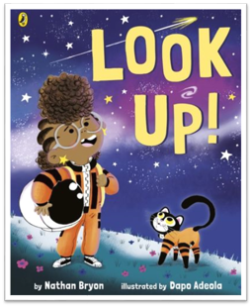Look Up! by ​Nathan Bryon |  | 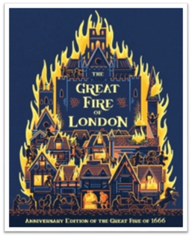  The Great Fire of London​  by ​ Emma Adams & James Weston Lewis |  | 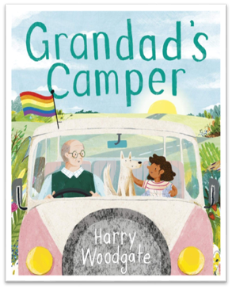Grandad’s Camper​  by ​Harry Woodgate |  | 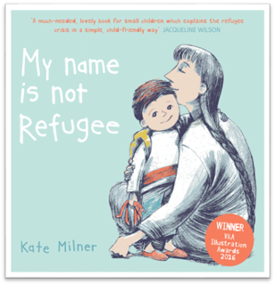  My name is not Refugee​  by ​ Kate Milner |  | 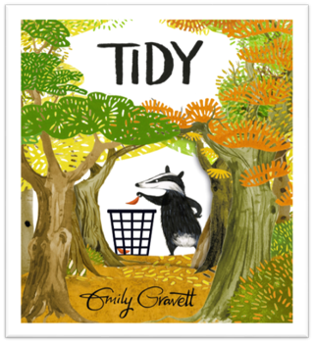  Tidy​ by ​ Emily Gravett |  |  | 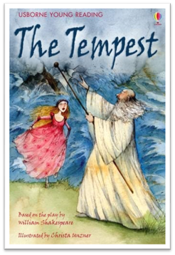  The Tempest​  Retold by Rosie Dickins
Maths | Number:  Place Value (within 10) | Number:  Addition and Subtraction (within 10) | Geometry: Shape | Number:  Place Value (within 20) | Addition and Subtraction (within 20) | Number:  Place Value (within 50) | Measurement:  Length and Height | Measurement:  Weight and Volume | Number: Multiplication and Division | Number: Fractions | Geometry: Position and Direction | Number:  Place Value (within 100) | Measurement: Money | Measurement:  Time
Science | Living things: Habitats |  | Living things: Microhabitats |  | Materials: Uses of everyday materials |  | Animals, including humans: Life cycles and health |  | Plants: Plant growth |  |  | Making connections: Plant- based materials
RE | Creation  Who made the world? |  | Universal  How should we care for the world and why does it matter?  Incarnation - Why does Christmas matter to Christians? |  | Humanism  What is humanism? |  | Salvation  Why does Easter matter to Christians? |  | Islam  Who is a Muslim and what do they believe? (Part 1) |  |  | Islam  Who is Muslim and what do they believe?  (Part 2)
Geography | Why we love Wrotham?  Are villages and cities different? |  |  |  | Explorers  How did Shackleton reach Antarctica? |  |  |  | Super South East  What is it like to live by the coast?
History |  |  | How was school different in the past? |  |  |  | How did Mankind learn to fly? |  |  |  |  | What is a monarch?
Computing |  |  | Presentation Skills |  |  |  | Online Safety |  |  |  |  | Programming, Turtle and Scratch
Art |  |  | Craft and Design: Map it Out |  |  |  | Painting and Mixed Media: Colour Mixing |  |  |  |  | Sculpture and 3D: Clay Houses
DT | Cooking and Nutrition: A Balanced Diet |  |  |  | Mechanisms: Levers |  |  |  | Structures: A Chair for a Bear
MfL | Explored through cultural celebrations
Music | Sing with accuracy, fluency, control and expression |  |  |  | Play tuned and untuned instruments with control |  |  |  | Listen and appraise a wide range of music
PE | Infant Agility& Football |  | Tag-Rugby & Gymnastics |  | Infant Agility & Orienteering |  | Tennis & Forest School |  | Athletics & Kwik Cricket |  |  | Athletics & Rounder
RHE/PSCHE | Relationships  Wellbeing |  |  |  | Keeping Safe  Wellbeing |  |  |  | Understanding the Law  Wellbeing
St. George’s Church of England Primary School – Long Term Planning Cedar Class Year 3

Year 3 | Autumn Term 1 |  | Autumn Term 2 |  | Spring Term 1 |  | Spring Term 2 |  | Summer Term 1 |  | Summer Term 2
Christian Value | Respect |  | Courage |  | Kindness |  | Forgiveness |  | Honesty |  | Hope
English text | 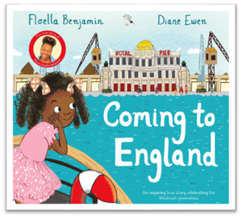  Coming to England by Floella Benjamin |  | 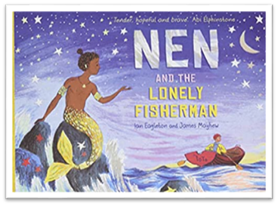  Nen and the Lonely Fisherman by ​  Ian Eagleton and James Mayhew​ |  | 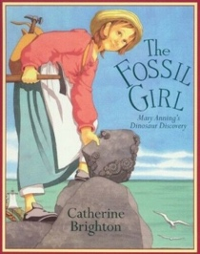  The Fossil Girl​ by Catherine Brighton​ |  | 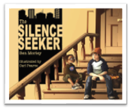  The Silence Seeker by Ben Morley |  | 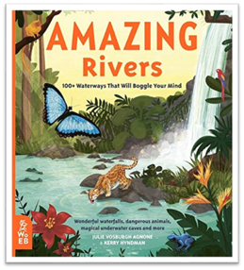 Amazing Rivers by Julie Vosburgh Agnone and Kerry Hyndman |  | 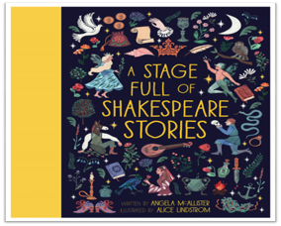  The Merchant of Venice ​from A Stage Full of Shakespeare Stories by Angela McAllister
Maths | Number:  Place Value | Number:  Addition and Subtraction | Number: Multiplication and Division | Measurement:  Length and Perimeter | Number:  Fractions | Measurement:  Mass and Capacity | Number:  Fractions | Measurement:  Money | Measurement:  Time | Geometry:  Shape | Geometry:  Statistics | Consolidation
Science | Animals: Movement and nutrition |  | Forces and Space: Forces and magnets |  | Materials: Rocks and soil |  | Energy: Light and Shadows |  | Plants: Plant reproduction |  | Making connections: How does handspan affect grip strength?
RE | People of God  What is it like to follow God? |  | Incarnation  What is the Trinity?  (Core) |  | Sikhi  What is important to Sikh people?  Christmas theme (2 lessons) |  | Sikhi  How do Sikh people worship and celebrate?  Salvation  Why do Christians call the day Jesus died ‘Good Friday’? |  | Kingdom of God  When Jesus left, what was the impact of Pentecost? |  | Humanism  What is humanism?
Geography | A view from above  Would you like a bird’s eye view? |  |  |  | Biomes  What on Earth are Biomes and why are they important? |  |  |  | Greece  How has Greece changed over time?
History |  |  | What did the Stone Age people Yabba dabba doo? |  |  |  | Why did the Romans settle in Britain? |  |  |  | What did the Ancient Egyptians believe?
Computing | Presentation Skills |  |  |  | Online Safety |  |  |  | Programming: Turtle and Scratch
Art |  |  | Drawing: Developing drawing skills |  |  |  | Painting and Mixed Media: Exploring texture with paint and collage |  |  |  | Sculpture and 3D: Abstract shape and space
DT | Cooking and Nutrition: Eating seasonally |  |  |  | Mechanical systems: Pneumatic toys |  |  |  | Textiles: Egyptian collars
MfL |  |  | Greetings  Numbers 0 – 15 |  |  |  | Days of the week  Months |  |  |  | Colours
Music | To read and understand Music notation (Music Plus year group)
PE | Tag-Rugby& Forest School * |  | Poplacrosse &Hockey |  | Gymnastics &Netball |  | Dance &Orienteering |  | Athletics &Kwik Cricket |  | Athletics & Rounders
RHE/PSCHE | Relationships  Wellbeing |  |  |  | Keeping Safe  Wellbeing |  |  |  | Understanding the Law  Wellbeing
St. George’s Church of England Primary School – Long Term Planning Willow Class Year 4

Year 4 | Autumn Term 1 |  | Autumn Term 2 |  |  | Spring Term 1 |  | Spring Term 2 |  |  | Summer Term 1 |  |  |  | Summer Term 2
Christian Value | Respect |  | Courage |  |  | Kindness |  | Forgiveness |  |  | Honesty |  |  |  | Hope
English text | 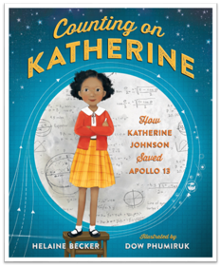  Counting on Katherine by Helaine Becker |  | 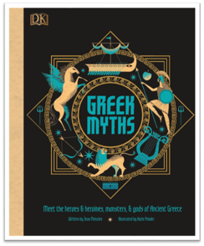  Greek Myths by Jean Menzies |  |  | 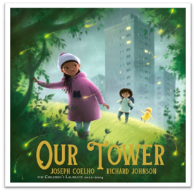  Our Tower​ by Joseph Coelho |  | 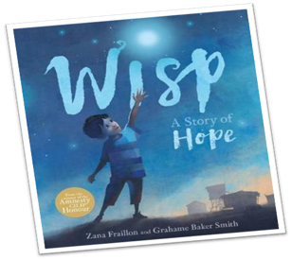  Wisp: A Story of Hope ​by Zana Fraillon |  |  | 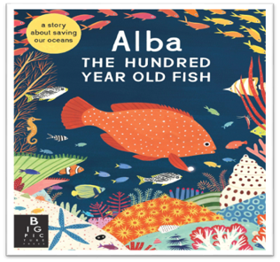  The Hundred Year Old Fish​ by Lara Hawthorne |  |  |  | 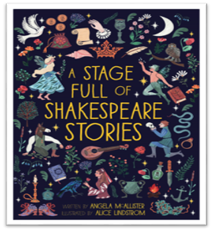  Julius Caesar – by William Shakespeare​ Edited by Angela McAllister​
Maths | Number:  Place Value | Number:  Addition and Subtraction | Geometry: Area |  | Number: Multiplication and division | Number:  Multiplication and division | Length and perimeter | Fractions |  | Decimals | Decimals |  | Money | Time | Shape | Statistics | Position and direction
Science | Animals including humans: Digestion and food |  | Energy: Electricity and circuits |  |  | Materials: States of matter |  | Energy: Sound and vibrations |  |  | Living things: Classification and changing habitats |  |  |  | Making connections: How does the flow of liquids compare?
RE | Creation  What do Christians learn from the Creation story? |  | Incarnation  What is the Trinity?  (Digging deeper) |  |  | Gospel  What kind of world did Jesus want? |  | Salvation  Why do Christians call the day Jesus died ‘Good Friday’?  (Core and Digging deeper) |  |  | Hindu Dharma  What does it mean to be a Hindu in Britain today?  (Part 1) |  |  |  | Hindu Dharma  What does it mean to be a Hindu in Britain today?  (Part 2)
Geography | Wrotham in the wider world -  How do geographical features shape our landscape? |  |  |  |  | Diving into Biomes -  What’s under the sea? |  |  |  |  | Mountains  How are mountains made?
History |  |  | How have children’s lives changed? |  |  |  |  | What changed in Britain after the Anglo – Saxon invasion? |  |  |  |  |  |  | How did the achievements of the Ancient Maya impact their society and beyond?
Computing |  |  | Presentation Skills |  |  |  |  | Online Safety |  |  |  |  |  |  | Programming: Turtle and Scratch
Art |  |  | Drawing: exploring tone, texture and proportion |  |  |  |  | Painting and Mixed Media: Light and Dark |  |  |  |  |  |  | Craft and Design: Fabric of Nature
DT | Cooking and Nutrition: Adapting a recipe |  |  |  |  | Structures: Helmets |  |  |  |  | Electrical systems: Exploring electrical products
MfL | What’s your name?  Numbers to 31 |  |  |  |  | What’s the date?  Tomorrow / yesterday |  |  |  |  | Body parts  Parts of the head
Music | Sing with accuracy, fluency, control and expression |  |  |  |  | Use and understand musical notations |  |  |  |  | Listen and appraise a wide range of music
PE | Tag-Rugby& Gymnastics |  | Poplacrosse& Forest School * |  |  | Hockey &Netball |  | Orienterring &Rounders |  |  | Athletics& Kwik Cricket |  |  |  | Athletics &Rounders
RHE/PSCHE | Relationships  Wellbeing |  |  |  |  | Keeping Safe  Wellbeing |  |  |  |  | Understanding the Law  Wellbeing
St. George’s Church of England Primary School – Long Term Planning Hazel Class Year 5

Year 5 | Autumn Term 1 |  |  | Autumn Term 2 |  | Spring Term 1 |  | Spring Term 2 |  |  |  |  | Summer Term 1 |  | Summer Term 2
Christian Value | Respect |  |  | Courage |  | Kindness |  | Forgiveness |  |  |  |  | Honesty |  | Hope
English text | 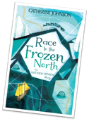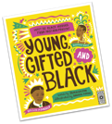  Young, Gifted and Black by Jamia Wilson​  Race to the Frozen North: The Matthew Henson Story by Catherine Johnson​ |  |  | 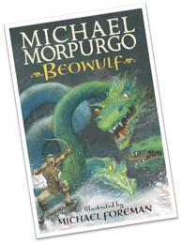  Beowulf by Michael Morpurgo​ |  | 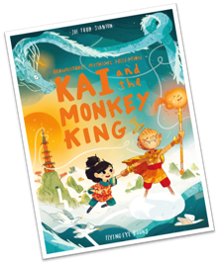  Kai and the Monkey King by Joe Todd-Stanton​ |  | 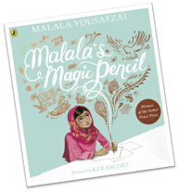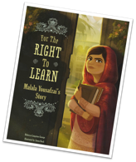  Malala’s Magic Pencil by Malala Yousafzai​  For the Right to Learn by Rebecca Langston-George |  |  |  |  | 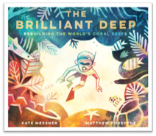  The Brilliant Deep by Kate Messner |  | 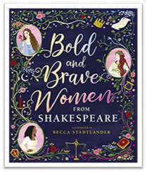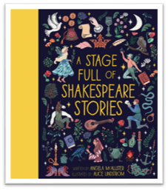  Bold and Brave Women from Shakespeare by Becca Stadtlander​  A Stage Full of Shakespeare Stories by Angela McAllister
Maths | Place Value | Addition & Subtraction |  | Multiplication & Division | Fractions A | Multiplication & Division | Fractions B | Decimals & percentages |  | Perimeter & Area | Statistics |  | Shape | Position & direction | Decimals |  | Negative numbers | Converting units | Volume
Science | Materials:  Mixture and separation |  | Materials: Properties and changes |  |  | Forces and space: Earth and Space |  | Living things: Life cycles and reproductions |  |  |  |  | Forces and space: Unbalanced forces |  | Making connections  Human timeline  Does the size of asteroid affect diameter of creater?
RE | God  What does it mean if God is loving and holy? |  |  | Incarnation  Was Jesus the Messiah?  (Core) |  | People of God  How can following God bring freedom and justice? |  | Salvation  What did Jesus do to save human beings? |  |  |  |  | Islam  What does it mean to be a Muslim in Britain today? (Part 1) |  | Islam  What does it mean to be a Muslim in Britain today? (Part 2)
Geography | Community, Country and Commonwealth  How far does Great Britain go? |  |  |  |  | Knowledge of the characteristics in the wider world.  Contrasts in Continent. |  |  |  |  |  |  | Rivers  Does water change the landscape?
History |  |  |  | Were the Vikings raiders, traders or settlers? |  |  |  | What did the Ancient Greeks do for us? |  |  |  |  |  |  | What was life like in Tudor times?
Computing | Radio Live |  |  |  |  | Online Safety  Unit 5.2 (3 lessons) |  |  |  |  |  | Scratch: developing games
Art |  |  |  | Sculpture and 3D: Interactive installation |  |  |  | Drawing :Depth, emotion and movement |  |  |  |  |  |  | Painting and mixed media: Expressive Portraits
DT | Electrical Systems: Wobble bots |  |  |  |  | Cooking and Nutrition: Developing a recipe |  |  |  |  |  |  | Textiles: Stuffed Toys
MFL |  |  |  | Simple conversation – combining greetings/family |  |  |  | family  masc and fem nouns |  |  |  |  |  |  | Pets  Adjectives
Music |  |  | Use and understand musical notations |  |  |  |  |  | Sing with accuracy, fluency, control and expression |  |  |  |  |  |  | Listen and appraise a wide range of music
PE | Tag-Rugby& Cricket * |  |  | Football &Hockey |  | Netball &Forest School * |  | Dance &Forest School |  |  |  |  | Athletics &Kwik Cricket |  | Athletics& Rounders
RHE/PSCHE | Relationships  Wellbeing |  |  | Keeping Safe  Wellbeing |  | Understanding the Law  Wellbeing |  | RHE/PSCHE |  |  |  |  | Relationships  Wellbeing |  | Keeping Safe  Wellbeing
Year 6 | Autumn Term 1 | Autumn Term 2 | Spring Term 1 | Spring Term 2 | Summer Term 1 |  | Summer Term 2
Christian Value | Respect | Courage | Kindness | Forgiveness | Honesty |  | Hope
English | 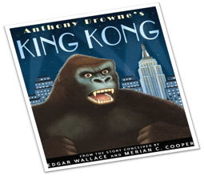King Kong by Anthony Browne | 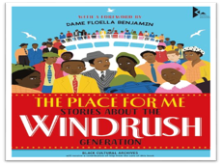  The Place For Me: Stories about the Windrush Generation​ by Dame Floella Benjamin et al | 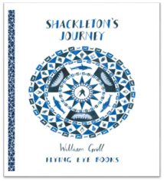  Shackleton’s Journey​ by William Grill | 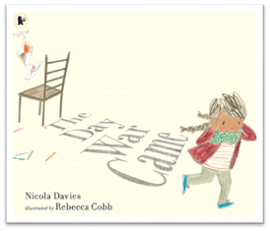  The Day War Came by Nicola Davies | 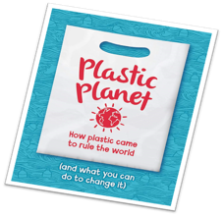  Plastic Planet: How plastic came to rule the world by Georgia Amson-Bradshaw​ |  | 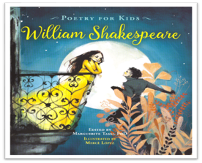  Poetry for Kids – William Shakespeare​  Edited by Marguerite Tassi
Maths | Place value  Four operations  Measurement | Fractions, decimals & percentages  Measurement:  Properties of shape | Position & direction  Algebra  Statistics | Measurement  Number & place value  Multiplication & division  Measurement  Fractions & decimals | Gap analysis/revision  Problem solving |  | Problem solving
Science | Living things: Classifying big and small | Energy: Light and reflection | Living things: Evolution and inheritance | Energy: Circuits, batteries and switches | Animals, including humans:  Circulation and health |  | Making connections:  Are some sunglasses safer than others?
RE | Creation  Creation and science - conflicting or complementary? | Gospel  What would Jesus do? | Humanism  What is humanism? | Judaism  What does it mean to be Jewish in Britain today?  Salvation  What difference does the resurrection make for Christians? (Short unit) | Universal  What can be done to reduce racism?  Can religion help? |  | Kingdom of God  What kind of King is Jesus?
Geography | Urban World—On the Edge  Why is London so powerful? |  | The Power of Mother Nature  How has Mother Earth shaped our landscape? |  | Looking forward to our future  How will our world change?
History |  | What does the Census tell us about our local area? |  | What was the impact of WW2 on the people of Britain? |  |  | Unheard Histories  Who should go on the bank note?
Computing |  | Spreadsheets |  | Online safety |  |  | Scratch: Animated stories
Art |  | Craft and Design: Photo opportunity |  | Drawing: expressing ideas |  |  | Sculpture and 3D: Making memories
DT | Structures: Playground Pioneers |  | Cooking and Nutrition: Come Dine with Me |  | Electrical systems: Steady hand game
MFL | Developing conversations |  | Seasons  Opinions |  | Clothes
Music | Use and understand musical notations |  | Listen and appraise a wide range of music |  |  | Sing with accuracy, fluency, control and expression
PE | Tag rugby &Cricket * | Football& Hockey | Orienteering &Netball | Gymnastics& Kwik Cricket | Athletics& Forest School * |  | Rounders &Forest School
RHE/PSCHE | Relationships  Wellbeing |  | Keeping Safe  Wellbeing |  | Understanding the Law  Wellbeing
St. George’s Church of England Primary School – Long Term Planning Sycamore Class Year 6

