Special Educational Needs and Disabilities (SEND) Information Report
St. George’s Church of England Primary School

Inclusion Team
SEND Governor:
Matthew Bournat
SENCO
Rachel Cunningham
Contact No. 01732 882 401
sen@st-georges-wrotham.kent.sch.uk

Approved by: | Full Governing Body | Date: 5th December 2025
Last reviewed on: | [tbc]
Next review due by: | September 2026

Contents
1. What types of SEND does the school provide for? 4
2. Which staff will support my child? 5
3. What should I do if I think my child has SEND? 7
4. What happens if the school identifies a need? 8
5. How will the school measure my child’s progress? 9
6. How will I be involved in decisions made about my child’s education? 10
7. How will my child be involved in decisions made about their education? 11
8. How will the school adapt its teaching for my child? 122
9. How will the school evaluate whether the support in place is helping my child? 133
10. How will the school ensure my child has appropriate resources? 133
11. How will the school make sure my child is included in activities alongside pupils who don’t have SEND? 144
12. How does the school make sure the admissions process is fair for pupils with SEN or a disability? 155
13. How does the school support pupils with disabilities? 155
14. How will the school support my child’s mental health and emotional and social development? 166
15. What support is in place for looked-after and previously looked-after children with SEN? 176
16. What support will be available for my child as they transition between classes or settings or in preparing for adulthood? 17
17. What support is available for me and my family? (Local Offer) 188
18. What should I do if I have a complaint about my child’s SEND support? 19
19. Supporting Documents…………………………………………………………………………………………………………….19
20. Glossary 20

Dear parents and carers,
The aim of this Information Report is to explain how we implement our SEND policy. In other words, we want to show you how SEND support works in our school.
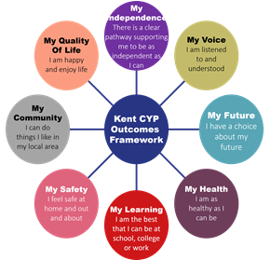
As educational professionals, we are all working towards the ultimate goal of growing independent young people as they prepare for adulthood. All provision and support we provide is working towards achieving the Kent Children and Young People (CYP) Outcomes Framework:

If you want to know more about our arrangements for SEND, read our SEND policy alongside this Information Report.
You can find our SEND policy on our website www.st-georges-wrotham.kent.sch.uk
Note: If there are any terms we’ve used in this information report that you’re unsure of, you can look them up in the Glossary at the end of the report.

1. What types of SEND does the school provide for?

Our school provides for pupils with the following needs (as outlined in the SEND Code of Practice 2015):

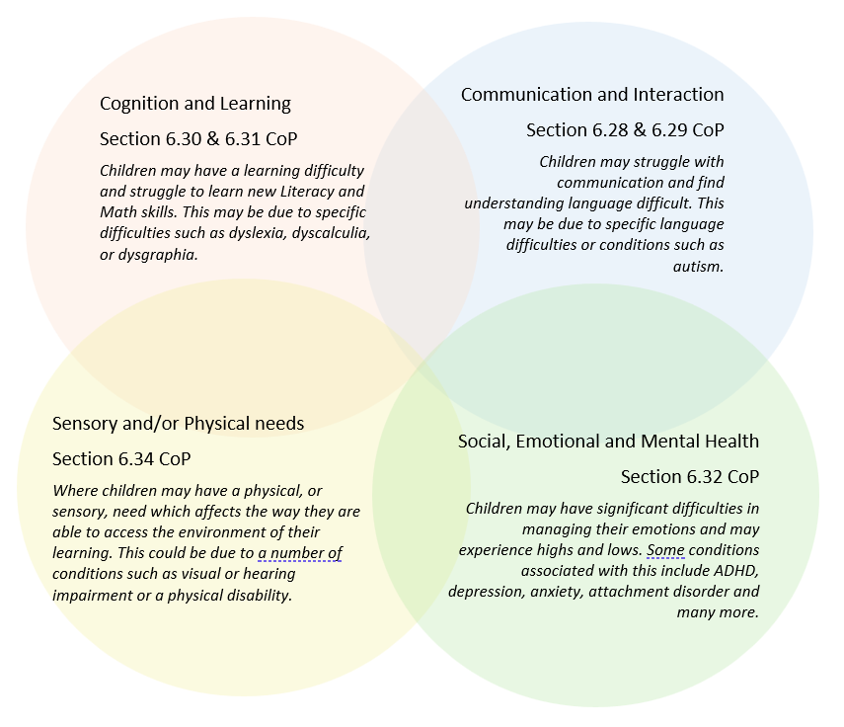

Often you will find that children’s needs overlap and are rarely confined to one area of need, which is why it is important to gain a wholistic overview of your child.
More information about the Areas of Need can be found in the Special educational needs and disability code of practice: 0 to 25 years (link below).
SEND_Code_of_Practice_January_2015.pdf (publishing.service.gov.uk)


2. Which staff will support my child, and what are their key responsibilities?

At St. George’s all staff are considered responsible for supporting the needs of pupils with SEND. Our staff are committed to regular, high-quality training to ensure that they have the knowledge and skills to better meet a wide range of pupil needs.
The school currently employs 7 Teaching Assistants who work directly with pupils. Additional funding obtained via High Needs Funding (where individual pupils are required to be supported) results in temporary contracts. We have 3 children in school receiving HNF, although this funding is only guaranteed for the academic year 2025-2026 due to schools entering a Communities of School model.

Our Special Educational Needs Co-ordinator, or SENCO
The named SENCO is Rachel Cunningham. She works at the school on Tuesday’s and Thursdays’ 9am – 3pm and on Wednesday’s 8am to 5pm. She can be contacted on sen@st-georges-wrotham.kent.sch.uk or alternatively by calling the school office on 01732 882 401

Class/subject teachers
All of our teachers receive in-house SEN training, and are supported by the SENCO to meet the needs of pupils who have SEN.
At St Georges Church of England School, we follow the Mainstream Core Standards advice developed by Kent County Council to ensure that our teaching conforms to best practice.

In meeting the Mainstream Core Standards, the school employs some additional teaching approaches, as advised by internal and external assessments. These include visual cues, social stories, sensory circuits, BEAM, social groups, ELSA, nurture groups and Language Link. These are delivered by additional staff employed through the funding provided to the school as ‘notional SEN funding’.

Teaching assistants (TAs)
We have a team of 7 TAs, including 3 higher-level teaching assistants (HLTAs) who are trained to deliver SEN provision throughout the whole school.

External agencies
Sometimes we need extra help to offer our pupils the support that they need. Whenever necessary we will work with external support services to meet the needs of our pupils with SEND and to support their families. These may include:

- Child and adolescent mental health services (CAMHS)
- Education welfare officers
- Educational psychologists
- GPs or paediatricians
- Occupational therapists
- Therapeutic practitioners
- Safeguarding services
- SEND Inclusion Advisor
- Specialist Teacher Service
- Speech and language therapists



- Voluntary sector organisation (such as foodbank, church etc)

3. What should I do if I think my child has SEND?

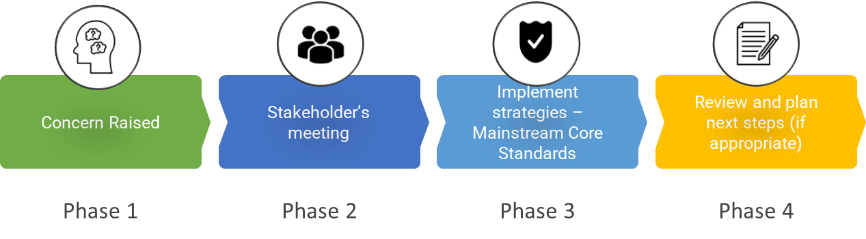

Phase 1 | If you think your child might have SEND, raise your concern with the school so that the SENCO is aware.  In the first instance; parents are to make contact with the class teacher. This can be done by calling the school office and making an appointment or by speaking with the class teacher directly.
Phase 2 | We will meet with you to discuss your concerns and try to get a better understanding of what your child’s strengths and difficulties are. Together we will decide what outcomes to seek for your child and agree on next steps. We will make a note of what’s been discussed and will begin our Internal Referral system, ensuring all information is added to your child’s record.
Phase 3 | We will implement the agreed strategies and monitor these over an agreed period of time. These are likely to be universal strategies set out in the mainstream core standards. A copy of this can be found here: https://www.kelsi.org.uk/__data/assets/pdf_file/0005/117257/Special-educational-needs-mainstream-core-standards-guide-for-parents.pdf . This will initiate the ‘Graduated Approach’ where support will be continually reviewed. See next page for more details.
Phase 4 | If we decide that your child needs SEND support, we will formally notify you via letter and your child will be added to the school’s SEND register. They will receive additional support and this will be reviewed using the assess, plan, do, review model via Provision plans.

4. What happens if the school identifies a need?
At St. George’s we follow an Internal Referral System if we or a parent has identified a concern.
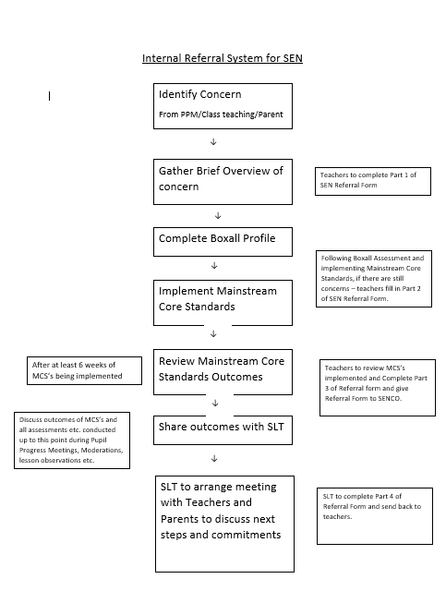
All our class teachers are responsible for the monitoring of all pupils who have been identified as having SEND. They also review those who are not making the expected level of progress in their schoolwork or socially.
If the teacher notices that a pupil is having difficulties, they try to find out if the pupil has any gaps in their learning. If they can find a gap, the school will provide appropriate support. Pupils who don’t have SEND usually make progress quickly once the gap in their learning has been filled.
If the pupil is still finding it difficult to make the expected progress, the teacher will talk to the SENCO, and will contact you to discuss the possibility that your child has SEND, and the school will follow the graduated approach (see previous page).

5. How will the school measure my child’s progress?

We will follow the ‘graduated approach’ to meeting your child’s SEND needs.
The graduated approach is a 4-part cycle of assess, plan, do, review.
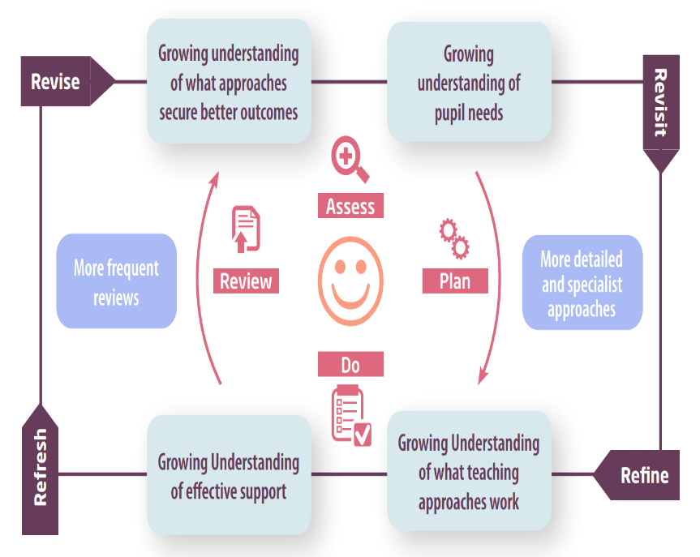

Assess | If your child is not making the expected level of progress, we will make an assessment to find out what strengths and difficulties your child has. We will ask for you and your child’s input, as well as getting help from external professionals where necessary.
Plan | In discussion with you and your child, we will decide what outcomes we are hoping to achieve. We will make a plan of the support we will offer your child to help them meet those outcomes. We will make a record of this and share it with you and all relevant school staff.
Do | We will put our plan into practice.  The class teacher, with the support of the SENCO, will be responsible for working with your child on a daily basis, and making sure the support we put in place is having the impact we intended.
Review | We will assess how well the support we put in place helped the pupil to meet the outcomes we set. We will use our improved understanding of your child’s needs to improve the support we offer; this may mean the Plan, Assess, Do, Review cycle continues.

6. How will I be involved in decisions made about my child’s education?
We will share a School Agreement outlining your child’s targets, three times a year and ask for your input. You will also receive a formal written report at the end of the year.
A member of staff who knows your child well will meet you at least twice a year to:
- Set clear outcomes for your child’s progress and to review progress towards those outcomes
- Discuss the support we will put in place to help your child make that progress
- Identify what we will do, what we will ask you to do, and what we will ask your child to do
The SENCO may also attend these meetings to provide extra support.
We know that you’re the expert when it comes to your child’s needs and aspirations. So, we want to make sure you have a full understanding of how we’re trying to meet your child’s needs, so that you can provide insight into what you think would work best for your child.
We also want to hear from you as much as possible so that we can build a better picture of how the SEND support we are providing is impacting your child outside of school.
If your child’s needs or aspirations change at any time, please let us know right away so we can keep our provision as relevant as possible.
If you have concerns that arise between these meetings, please contact your child’s class teacher, the school office or the Senco.
Building positive relationships is key to ensuring parents are fully involved in deciding the right educational setting for their child. Through building these relationships we are able to have honest and open discussions about the pupils’ strengths and weaknesses and how these can be best supported and nurtured to ensure the pupil reaches their full potential. When considering specialist educational provision, the SENCO supports parents in their decision by accompanying them to visit local specialist settings where they are supported to ask questions and make a decision that is not rushed.
Early discussions are had with parents or children whose academic progress is slow compared to that of their peers. During these discussions we will ensure that:
- Everyone develops a good understanding of the pupils’ strengths and difficulties
- We take into account parents’ concerns
- Everyone understands the agreed outcomes sought for the child
- Everyone is clear on what the next steps are

7. How will my child be involved in decisions made about their education?

The level of involvement will depend on your child’s age and individual needs. We recognise that no two pupils are the same, so we will decide on a case-by-case basis, with your input.
We may seek your child’s views by asking them to:
- Attend meetings to discuss their progress and outcomes
- Chat with class teacher/TA to create their school agreements
- Discuss their views with a member of staff who can act as a representative during the meeting
- Complete a survey



8. How will the school adapt its teaching for my child?
Your child’s teacher is responsible and accountable for the progress and development of all the pupils in their class.
High-quality teaching is our first step in responding to your child’s needs. We will make sure that your child has access to a broad and balanced curriculum in every year they are at our school.
We will adapt our approaches to how we teach to suit the way the pupil works best. There is no 'one size fits all’ approach to adapting the curriculum, we work on a case-by case basis to make sure the adaptations we make are meaningful to your child and are guided by the Mainstream Core Standards in the first instance.

These adaptations may include:
- Adapting our approaches, for example, giving longer processing times, pre-teaching of key vocabulary, reading instructions aloud, etc.

- Adapting our resources and staffing

- Using recommended aids, such as laptops, coloured overlays, visual timetables, larger font, etc.

- Teaching assistants or support staff will support pupils appropriately depending on their presentation of need

- Scaffolding lesson materials
We may also provide the following interventions:
- Nessy – computer programme for Dyslexia
- Sensory Circuits
- BEAM – Balance Education and Movement
- Speech Link
- Language Link
- Draw and Talk
- Clever Fingers
- Write from the start
- Phonics interventions
- Zones of Regulation
- Lego Therapy sessions
- Memory Magic
- ELSA Programme
These interventions are part of our contribution to Kent County Council’s local offer.

9. How will the school evaluate whether the support in place is helping my child?

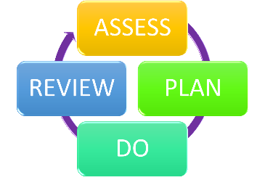
We will evaluate the effectiveness of provision for your child by:
- Reviewing their progress towards their goals each term through Pupil Progress Meetings
- Reviewing the impact of interventions after 12 weeks
- Using pupil questionnaires
- Monitoring by the SENCO
- Using provision maps to measure progress
- Holding an annual review (if they have an education, health and care (EHC) plan)

10. How will the school ensure my child has appropriate resources?
From September 2025, all Kent schools will be following a Community of Schools Model whereby we will have to apply for funding through our community as opposed to in previous years creating an application for High Needs Funding.
It may be that your child’s needs mean we need to provide additional resources such as:
- Additional resources to support their learning
- Adaptations to in class support
- Further training for our staff
- External specialist expertise
Where appropriate, we will consult with external agencies to get recommendations on what will best help your child access their learning and use our best endeavours to ensure these are supplied.

11. How will the school make sure my child is included in activities alongside pupils who don’t have SEND?
All clubs, trips and activities offered to pupils at St Georges are available to pupils with special educational needs either with or without an Education, Health and Care Plan. Where it is necessary, the school will use the resources available to it to provide additional adult support to enable the safe participation of the pupil in the activity as well as writing a Risk Assessment if this is required.
All pupils are encouraged to go on our school trips, including our residential trips.
All pupils are encouraged to take part in Sports day, school performances and any special workshops that the school may have.
No pupil is ever excluded from taking part in these activities because of their SEN or disability and we will make whatever reasonable adjustments are needed to make sure that they can be included as much as possible.

12. How does the school make sure the admissions process is fair for pupils with SEN or a disability?

Kent are responsible for the general admissions to our school. When we are provided with our admissions list for our new Reception intakes, the SENCO works closely with the Reception class teachers and together ensure they make contact with all pre-school settings of pupils’ joining St. George’s.
The SENCO visits certain settings if a concern for SEN or Safeguarding may have been raised. Notes are collated with all staff involved to ensure a profile of the children is generated and measures can be put in to place prior to September.
During the Induction ‘Stay and Play’ mornings at school in the Summer Term, the SENCO meets with parents of our new intake to discuss their child’s needs and any other concerns their parents may have. This is a really good opportunity to start forming relationships with our new parents.

13. How does the school support pupils with disabilities?
You’re disabled under the Equality Act 2010 if you have a physical or mental impairment that has a ‘substantial’ and ‘long-term’ negative effect on your ability to do normal daily activities.
See Accessibility Plan on our school website.

14. How will the school support my child’s mental health and emotional and social development?
As a Christian school, we worked together as a team involving, pupils, staff, governors and parents to choose the following six Christian values representative of our Church of England school. Our Christian values inform every aspect of our school community life, and are embedded in all our policies.
Each term we focus on a different Christian Value. This is done explicitly through our Collective Worship time and also throughout our curriculum. Children have regular opportunities to reflect on each value and to develop an understanding of the Value in action. Each Friday, in our vision in practice Worship, we acknowledge children who have demonstrated these values.
RESPECT
- ‘Treat others as you want to be treated.' (Luke 6:31)

HONESTY
- 'Let us not love with words or speech but with actions and in truth.' (1 John 3:18)
COURAGE
- 'Be strong, be courageous. Do not be afraid; do not be discouraged, for the Lord your God will be with you wherever you go.' (Joshua 1:9)

KINDNESS
- ‘Do not let kindness and truth leave you.' (Proverbs 3:3)

FORGIVENESS
- 'Be kind to one another, tender hearted, forgiving one another, as God in Christ forgave you.' (Ephesians 4:32)
HOPE

- ‘No one who hopes in you will ever feel shame.' (Psalm 25:3)
All pupils within our school are part of a community and part of a family – this is hugely promoted through our shared vision throughout the school.

In addition to this, our SENCO is a qualified ELSA (Emotional Literacy support assistant) who works with pupils’ that have been identified by staff or parents as requiring some support for their SEMH needs.
We have also been incredibly lucky to have input this year from a Play therapist and a Counselor from Spurgeons to meet the needs of some of our more complex pupils’.

15. What support is in place for looked-after and previously looked-after children with SEND?


The Headteacher (Elizabeth Rye) and the SENCO (Rachel Cunningham) will work with all teachers at St. George’s to ensure that they understand how a looked-after or previously looked-after pupil’s circumstances and their SEND might interact, and what the implications there may be for teaching and learning.
Pupils who are looked-after or previously looked-after will be supported much in the same way as any other child who has SEND. However, looked-after pupils will also have a personal education plan (PEP). We will make sure that the PEP and any SEND support plans or EHC plans are consistent and complement one another.

16. What support will be available for my child as they transition between classes or settings or in preparing for adulthood?
Between years

To help pupils with SEND be prepared for a new school year we:
- Schedule lessons with the incoming teacher towards the end of the summer term
- Current teacher writes a Provision Plan for the new teacher which they share in the summer term in preparation for September, identifying the provisions that they need for the new academic year and handover the SEN file, outlining the profile of need within the class
Between schools
When your child is moving on from our school, we make contact with the new school and handover any relevant information that would support your child.

Primary to Secondary
The SENCO of the secondary school will come into our school for a meeting with our SENCO. They will discuss the needs of all the pupils who are receiving SEND support.
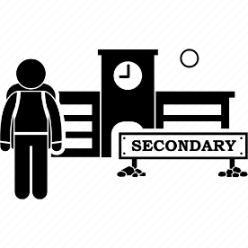
Pupils will be prepared for the transition by:
- Practising with a secondary school timetable
- Learning how to get organised independently
- Plugging any gaps in knowledge
- Additional transition sessions if required

17. What support is available for me and my family?
If you have questions about SEND, or are struggling to cope, please get in touch to let us know. We want to support you, your child and your family.
To see what support is available to you locally, have a look on Kelsi website and Kent’s Local Offer.
About the SEND local offer - Kent County Council

18. What should I do if I have a complaint about my child’s SEND support?
Complaints about SEND provision in our school should be made to the Class teacher, Senco and Headteacher in the first instance. They will then be referred to the school’s complaints policy.
If you are not satisfied with the school’s response, you can escalate the complaint. In some circumstances, this right also applies to the pupil themselves.
To see a full explanation of suitable avenues for complaint, see pages 246 and 247 of the SEND Code of Practice.
If you feel that our school discriminated against your child because of their SEND, you have the right to make a discrimination claim to the first-tier SEND tribunal. To find out how to make such a claim, you should visit: https://www.gov.uk/complain-about-school/disability-discrimination
You can make a claim about alleged discrimination regarding:
- Admission
- Exclusion
- Provision of education and associated services
- Making reasonable adjustments, including the provision of auxiliary aids and services
Before going to a SEND tribunal, you can go through processes called disagreement resolution or mediation, where you try to resolve your disagreement before it reaches the tribunal.
Mediation and Resolution - KELSI

19. Supporting documents

- Equality Information and Objectives Policy
- Child protection and safeguarding policy
- Behaviour Policy
- Accessibility Plan
- Attendance and punctuality policy
- SEND policy

- SEN & Disabilities Code Of Practice 2015
- Mainstream Core Standards

20. Glossary
- Access arrangements – special arrangements to allow pupils with SEND to access assessments or exams
- Annual review – an annual meeting to review the provision in a pupil’s EHC plan
- Area of need – the 4 areas of need describe different types of needs a pupil with SEND can have. The 4 areas are communication and interaction; cognition and learning; physical and/or sensory; and social, emotional and mental health needs.
- CAMHS – child and adolescent mental health services
- Differentiation – when teachers adapt how they teach in response to a pupil’s needs
- EHC needs assessment – the needs assessment is the first step on the way to securing an EHC plan. The local authority will do an assessment to decide whether a child needs an EHC plan.
- EHC plan – an education, health and care plan is a legally-binding document that sets out a child’s needs and the provision that will be put in place to meet their needs.
- First-tier tribunal/SEND tribunal – a court where you can appeal against the local authority’s decisions about EHC needs assessments or plans and against discrimination by a school or local authority due to SEND
- Graduated approach – an approach to providing SEND support in which the school provides support in successive cycles of assessing the pupil’s needs, planning the provision, implementing the plan, and reviewing the impact of the action on the pupil
- Intervention – a short-term, targeted approach to teaching a pupil with a specific outcome in mind
- Local offer – information provided by the local authority which explains what services and support are on offer for pupils with SEND in the local area
- Outcome – target for improvement for pupils with SEND. These targets don't necessarily have to be related to academic attainment
- Reasonable adjustments – changes that the school must make to remove or reduce any disadvantages caused by a child’s disability
- SENCO – the special educational needs co-ordinator
- SEN – special educational needs
- SEND – special educational needs and disabilities
- SEND Code of Practice – the statutory guidance that schools must follow to support pupils with SEND
- SEND information report – a report that schools must publish on their website, that explains how the school supports pupils with SEND
- SEND support – special educational provision which meets the needs of pupils with SEND
- Transition – when a pupil moves between years, phases, schools or institutions or life stages

