# 

**Behaviour for Learning Policy**

**(including exclusions)**

**Reviewed: September 2023**

**Next Review: September 2024**

**St George’s Church of England Primary School**



**Ratified by the Full Governing Body**

**September 2023**

**This policy is underpinned by our Christian Values:**

**Respect Courage Kindness Forgiveness Honesty Hope**

**Introduction:**

DfE Guidelines have been taken into consideration in the formation of this policy. It should be read in conjunction with other related policies to establish the vision, ethos and values of the school.

**Rationale:**

At St George’s CE Primary School our vision is ‘Bringing Faith and Education Together’ where our children’s faith in God directs them on the right path to become confident and self-assured learners. We believe that children thrive best in a well-disciplined caring environment. We have a responsibility to develop children’s understanding of the importance of our British and Christian values in recognising what good behaviour looks like; and to teach them strategies to help them make appropriate choices.

**We believe that:**

Every child has the right to learn and good behaviour is essential in allowing our children to achieve their full potential and ‘let their light shine’ (Matthew 5:16). Good behaviour promotes effective learning; and effective teaching and learning promotes good behaviour. Our core Christian values which are embedded across the school and help give the children a firm grounding upon which to live their life.

A school with a sound, positive and caring ethos is therefore essential for learning. It depends upon developing relationships with a high degree of trust, and putting in place a process of cooperative teamwork. The school therefore welcomes and encourages the involvement of the LEA, Governors, parents and others in the community.

We believe in a culture of inclusion, equal opportunities and respect for all members of our community and in the importance of self-discipline and self-esteem.

Discrimination of any form is not tolerated. No one should be allowed to behave in a way that adversely affects the learning, well-being and school experience of others.

We also recognise that children with emotional and behavioural needs need support to achieve these standards of behaviour.

**We expect:**

|  |  |
| --- | --- |
| **Learners to:** | **Adults to:** |
| Contribute to a warm, caring positive ethos focused on our values of respect, courage, kindness, forgiveness, honesty and hope  Consistently use positive language which refers explicitly to our values towards others in our community  Behave positively towards others in our school community, actively demonstrating our Christian values, treating everyone with consideration and respect and ensuring freedom from bullying, harassment and discrimination.  Assess and manage risks appropriately and keep themselves safe  Be a good role model for others and ambassadors for the school  Have good attendance and punctuality at school and in lessons  Respond to adults high expectations by being enthusiastic, persevering and self-motivated, accepting mistakes as part of learning  Engage in all lessons and learning experiences to ensure good progress is made, avoiding the disruption of others  Support and encourage one another  Respect and work within our behaviour management procedures  Demonstrate positive behaviour on any part of our school site, on and off, at any time while they are representing our school | Contribute to a warm, caring positive ethos focused on our values of respect, courage, kindness, forgiveness, honesty and hope  Consistently use positive language which refers explicitly to our values towards others in our community  Behave positively towards others in our school community, actively demonstrating our Christian values, treating everyone with consideration and respect and ensuring freedom from bullying, harassment and discrimination.  Ensure that learners are safe and feel safe and secure in the school environment  Be a good role model for others and ambassadors for the school  Have good attendance and punctuality at school and in lessons  Have high expectations of pupils and to ensure that all pupils have an equal and fair chance to thrive and learn in an atmosphere of respect and dignity  Plan and teach interesting and engaging lessons that enables all learners to make good progress  Support and encourage one another  Apply our behaviour management strategies consistently, fairly and transparently  Demonstrate positive behaviour on any part of our school site, on and off, at any time while they are representing our school by  adhering to the Teachers’ Standards, part 2 regarding Personal and Professional conduct |

**Please see Appendix 1 for full details of our behaviour management strategies**

**EXCLUSION**

In keeping with our values, a decision to exclude a pupil externally, either for a fixed period or permanently, is seen always a last resort.

No exclusion will be initiated without first exhausting other strategies or, in the case of a serious single incident, a thorough investigation.

Reasons for exclusion:

* Serious breach of the school’s values or policies
* Risk of harm to the education or welfare of the pupil or others in the school

The decision to exclude a child from the school can only be taken by the Headteacher, and only when no other course of action can achieve the same objectives.

Exclusion will not be used for minor incidents e.g. failure to do homework, lateness, poor academic performance or breaches of uniform rules.

**Suspension (exclusion for a fixed period)**

Suspension will be for the shortest time necessary. Suspension for a period of time from half a day to 5 days for persistent or cumulative problems would be imposed only when the school had already offer implemented a range of support and management strategies.

Suspension may be used for a single serious incident. In such cases the Headteacher will investigate the incident thoroughly and consider all evidence to support the allegation, taking account of the school’s policies. The pupil will be encouraged to give his/her version of events and the Headteacher will check whether the incident may have been provoked, for example by bullying or racial harassment.

**Permanent exclusion**

A permanent exclusion is a very serious decision. As with a suspension, it will follow a range of strategies and be seen as a last resort, or it will be in response to a very serious breach of school rules and policies or a disciplinary offence such as:

* Serious actual or threatened violence against another pupil or a member of staff
* Possession or use of an illegal drug on school premises
* Carrying an offensive weapon
* Persistent bullying
* Racial harassment

If the headteacher decides to exclude a pupil they will comply with statutory procedures.

**Pupils with special educational needs, and disabled pupils**

The school will take account of any special educational needs when considering whether or not to exclude a pupil. We have a legal duty under the Disability Discrimination Act 1995 as amended not to discriminate against disabled pupils by excluding them from school for behaviour related to their disability. The headteacher will ensure that reasonable steps have been taken by the school to respond to a pupil’s disability so the pupil is not treated less favourably for reasons related to the disability.

**Pupils with additional behaviour support** There will be occasions when some pupils find it difficult to work within the identified system of sanctions and rewards. These pupils require additional behaviour support. Allocation of additional support will be agreed with parents and carers after a full discussion of the child’s needs. At this point the child will be placed on the school monitoring SEN register and a range of strategies and resources will be considered.

It is vital that records are kept of all behavioural incidents. This helps to safeguard children and to build a full and accurate picture of their needs. (See Inclusion Policy)

**Positive Handling/Reasonable Force**

Positive Handling uses the **minimum** degree of force necessary for the **shortest period of time** to prevent a pupil harming himself, herself, others or property.

The scale and nature of any physical intervention must be **proportionate** to both the behaviour of the individual to be controlled, and the nature of the harm they might cause.

Staff would be expected to follow the Behaviour Policy in the first instance to manage an incident/challenging behaviour and will have had Team Teach training.

Wherever possible, assistance should be sought from another member of staff before intervening.

**Physical intervention may involve staff:**

* escorting a pupil
* shepherding a pupil away
* supportively holding a pupil to keep them or others safe until they have regained control of themselves or can be supported to an area to calm down

All incidents necessitating positive handling will be recorded and reported termly.

**Other Policy Links**

This policy should be read in conjunction with the Home-School Agreement, SEN policy, Anti-bullying policy, PSCHE policy, Safeguarding Policies, Disability & Accessibility Policy & Plan and the Teaching and Learning (Curriculum) Policy

**Monitoring**

The Senior Leadership Team and Governors will continually monitor and evaluate the behaviour throughout the school, and the effectiveness of this policy and the school’s procedures. Agreed changes will then be made as necessary.

Appendices

1. Whole School Approach to Good Behaviour
2. Behaviour Values
3. Behaviour Consequences

APPENDIX 1

W**hole School Approach:**

At St. George’s C of E Primary School, we want to uphold the school’s Christian values: Respect, Courage, Kindness, Forgiveness, Honesty and Hope.

We are focusing very much on the positive and the children will still receive stickers, house points, dojos, achievement rewards, ‘Golden Reward Time’ and certificates for good behaviour. For exceptional behaviour and attributes reflecting the school’s vision, one child per term in each class will be chosen to receive the Achievement Cup.

In addition, we promote behaviour so that everyone feels safe, respects one another, treats each other nicely, and looks after equipment and possessions.

Further to this there will be progressive actions, dependent on age, if these behaviours are not adhered to within our school community.

**Behaviour Management In Class:**

Good planning for learning is the first step towards positive behaviour management in class. This involves clear differentiation, motivating and engaging children and building their self-esteem. Adults should provide support for children in a positive way which prevents low level disruption from becoming more serious.

Children will be encouraged through positive behaviour strategies.

Each class teacher is to be responsible for determining rules, rewards and consequences with the class.

* School Behaviour Values should be shared with the children (see Appendix 2)
* Children should be provided with positive rewards for good behaviour eg verbal or written praise, house points, certificates, free choice etc.
* Children should be involved in discussing and determining rewards.
* Expectations should be displayed in the classroom and children reminded of them regularly.
* Children should be made aware of sanctions involved in breaking the rules, so that they

have the opportunity to modify their behaviour (see Appendix 3)

* Blank timetables can be used to identify any pattern in regular bad behaviour.
* Bullying, whether verbal or physical, is unacceptable and the child being victimised should be removed from the situation immediately.
* Playtime detention: Teachers should always remain in the class with children staying in.

**Class Dojo**

The Class Dojo scheme is to be used as a tool for positive praise in school. Children can be given Dojo points from the teacher for a number of different reasons (effort. Respectfulness, etc). This can also be used as a communication tool with parents. Keeping them up to date with how their child/children are getting on in school.

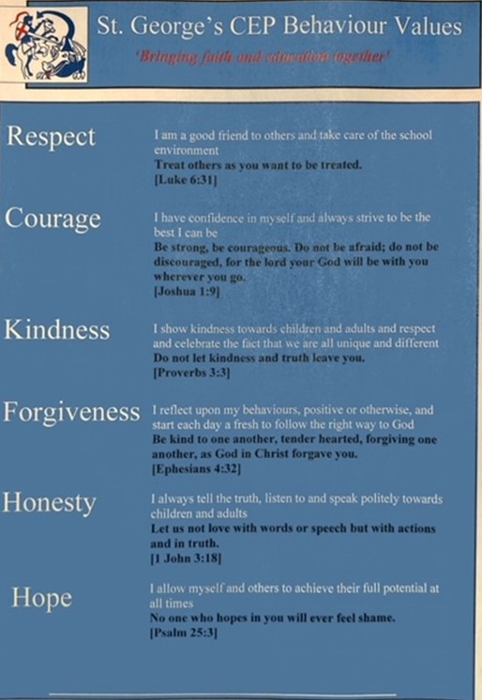

APPENDIX 3

**Behaviour Flow Chart**

Not following Behaviour Values

Sit in another place / remove from distraction

Warning – name on board

Second warning – name on board

Break missed

Negative behaviour continues

Member of SLT involved to discuss

Headteacher involvement

Second time with SLT

Classroom Management

SLT to speak with parents